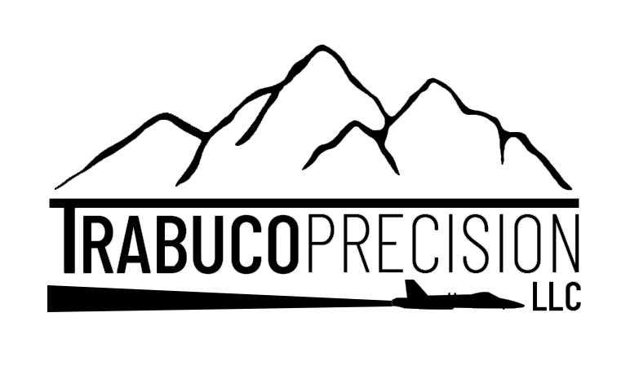

**QUALITY POLICY:**

Trabuco Precision is committed to meeting or exceeding our Customer's expectations. Provide superior first-time quality products along with on-time delivery performance. Comply with all safety, applicable statutory, regulatory and international standards. Our team is firmly committed to “Continuous Improvement” in the effectiveness of our Quality Management System & Customer Satisfaction.

**SCOPE:**

Manufacturing of precision machined parts and assemblies for the aerospace, defense, medical and commercial industries.